**Project Design Phase**

**Solution Architecture**

|  |  |
| --- | --- |
| Date | 27 June 2025 |
| Team ID | LTVIP2025TMID42022 |
| Project Name | Hematovision: Advanced Blood Cell Classification Using Transfer Learning |
| Maximum Marks | 4 Marks |

**Solution Architecture:**

**Solution architecture is a complex process – with many sub-processes – that bridges the gap between healthcare problems and AI-powered technology solutions. Its goals in this project are to:**

* **Find the best deep learning solution to automate and enhance blood cell classification.**
* **Describe the structure, characteristics, behaviour, and other aspects of the AI system to healthcare stakeholders.**
* **Define features, model development phases, and data handling requirements.**
* **Provide specifications according to which the solution is trained, validated, managed, and deployed in medical environments.**

**Example - Solution Architecture Diagram:**

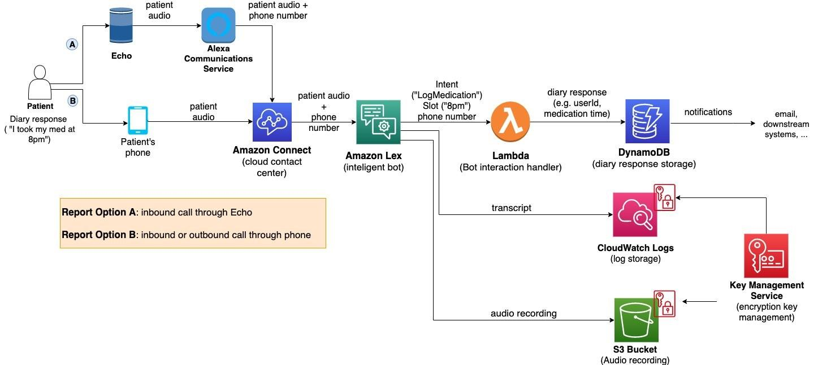

*Figure 1: Architecture and data flow of the voice patient diary sample application*

**• Input: Microscopic Blood Cell Image**

**• Model Pipeline: Image Preprocessing → Transfer Learning (ResNet/VGG) → CNN Classifier**

**• Output: Classified Cells (RBC, WBC, Platelets, Abnormal Cells)**

**• Interface Layer: Web/Cloud Interface for Healthcare Professionals**

**• Storage: Secure Cloud Database with Report Generation**

**Reference:** [**https://aws.amazon.com/blogs/industries/voice-applications-in-clinical-research-powered-by-ai-on-aws-part-1-architecture-and-design-considerations/**](https://aws.amazon.com/blogs/industries/voice-applications-in-clinical-research-powered-by-ai-on-aws-part-1-architecture-and-design-considerations/)